Chapter 19, Solution 1.

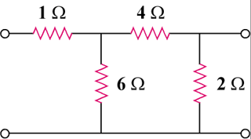
Obtain the z parameters for the network in Fig. 19.65.

8 Ω

4 Ω

12 Ω

2 Ω

8 Ω

2 Ω


4 Ω

12 Ω

Figure 19.65
For Prob. 19.1.

Solution

To get and , consider the circuit in Fig. (a).

I₂ = 0

12

8

4

+

V₁

2

I₁

(a)

I_{o}

+

V₂

,

To get and , consider the circuit in Fig. (b).

12

8

4

+

V₁

+

V₂

I₂

I₁ = 0

2

(b)

I_{o}'

,

Hence,

